R Notebook

library(survival)

knitr::include_graphics("8_3.PNG")

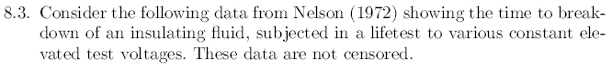

voltages <- read.csv("voltages.csv", header = T, sep = ",")  
str(voltages)

## 'data.frame': 60 obs. of 3 variables:  
## $ time: num 7.74 17.05 20.46 21.02 22.66 ...  
## $ KV : int 30 30 30 30 30 30 30 30 30 30 ...  
## $ cens: int 1 1 1 1 1 1 1 1 1 1 ...

knitr::include_graphics("8_31.PNG")

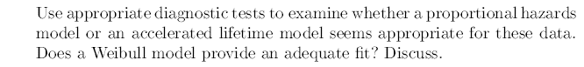

voltages$KV <- as.factor(voltages$K)  
km.voltages <- survfit(Surv(time,cens)~KV, data=voltages)  
summary(km.voltages)

## Call: survfit(formula = Surv(time, cens) ~ KV, data = voltages)  
##   
## KV=30   
## time n.risk n.event survival std.err lower 95% CI upper 95% CI  
## 7.74 11 1 0.9091 0.0867 0.7541 1.000  
## 17.05 10 1 0.8182 0.1163 0.6192 1.000  
## 20.46 9 1 0.7273 0.1343 0.5064 1.000  
## 21.02 8 1 0.6364 0.1450 0.4071 0.995  
## 22.66 7 1 0.5455 0.1501 0.3180 0.936  
## 43.40 6 1 0.4545 0.1501 0.2379 0.868  
## 47.30 5 1 0.3636 0.1450 0.1664 0.795  
## 139.07 4 1 0.2727 0.1343 0.1039 0.716  
## 144.12 3 1 0.1818 0.1163 0.0519 0.637  
## 175.88 2 1 0.0909 0.0867 0.0140 0.589  
## 215.10 1 1 0.0000 NaN NA NA  
##   
## KV=32   
## time n.risk n.event survival std.err lower 95% CI upper 95% CI  
## 0.27 15 1 0.9333 0.0644 0.8153 1.000  
## 0.40 14 1 0.8667 0.0878 0.7106 1.000  
## 0.69 13 1 0.8000 0.1033 0.6212 1.000  
## 0.79 12 1 0.7333 0.1142 0.5405 0.995  
## 2.75 11 1 0.6667 0.1217 0.4661 0.953  
## 3.91 10 1 0.6000 0.1265 0.3969 0.907  
## 9.88 9 1 0.5333 0.1288 0.3322 0.856  
## 13.95 8 1 0.4667 0.1288 0.2717 0.802  
## 15.93 7 1 0.4000 0.1265 0.2152 0.743  
## 27.80 6 1 0.3333 0.1217 0.1630 0.682  
## 53.24 5 1 0.2667 0.1142 0.1152 0.617  
## 82.85 4 1 0.2000 0.1033 0.0727 0.550  
## 89.29 3 1 0.1333 0.0878 0.0367 0.484  
## 100.58 2 1 0.0667 0.0644 0.0100 0.443  
## 194.90 1 1 0.0000 NaN NA NA  
##   
## KV=34   
## time n.risk n.event survival std.err lower 95% CI upper 95% CI  
## 0.19 19 1 0.9474 0.0512 0.85210 1.000  
## 0.78 18 1 0.8947 0.0704 0.76686 1.000  
## 0.96 17 1 0.8421 0.0837 0.69312 1.000  
## 1.31 16 1 0.7895 0.0935 0.62589 0.996  
## 2.78 15 1 0.7368 0.1010 0.56321 0.964  
## 3.16 14 1 0.6842 0.1066 0.50411 0.929  
## 4.15 13 1 0.6316 0.1107 0.44800 0.890  
## 4.67 12 1 0.5789 0.1133 0.39455 0.850  
## 4.85 11 1 0.5263 0.1145 0.34355 0.806  
## 6.50 10 1 0.4737 0.1145 0.29488 0.761  
## 7.35 9 1 0.4211 0.1133 0.24851 0.713  
## 8.01 8 1 0.3684 0.1107 0.20449 0.664  
## 8.27 7 1 0.3158 0.1066 0.16291 0.612  
## 12.06 6 1 0.2632 0.1010 0.12401 0.558  
## 31.75 5 1 0.2105 0.0935 0.08814 0.503  
## 32.52 4 1 0.1579 0.0837 0.05590 0.446  
## 33.91 3 1 0.1053 0.0704 0.02838 0.390  
## 36.71 2 1 0.0526 0.0512 0.00781 0.355  
## 72.89 1 1 0.0000 NaN NA NA  
##   
## KV=36   
## time n.risk n.event survival std.err lower 95% CI upper 95% CI  
## 0.35 15 1 0.9333 0.0644 0.8153 1.000  
## 0.59 14 1 0.8667 0.0878 0.7106 1.000  
## 0.96 13 1 0.8000 0.1033 0.6212 1.000  
## 0.99 12 1 0.7333 0.1142 0.5405 0.995  
## 1.69 11 1 0.6667 0.1217 0.4661 0.953  
## 1.97 10 1 0.6000 0.1265 0.3969 0.907  
## 2.07 9 1 0.5333 0.1288 0.3322 0.856  
## 2.58 8 1 0.4667 0.1288 0.2717 0.802  
## 2.71 7 1 0.4000 0.1265 0.2152 0.743  
## 2.90 6 1 0.3333 0.1217 0.1630 0.682  
## 3.67 5 1 0.2667 0.1142 0.1152 0.617  
## 3.99 4 1 0.2000 0.1033 0.0727 0.550  
## 5.35 3 1 0.1333 0.0878 0.0367 0.484  
## 13.77 2 1 0.0667 0.0644 0.0100 0.443  
## 25.50 1 1 0.0000 NaN NA NA

plot(km.voltages, conf.int=F,col=c("red", "blue", "green", "orange"), xlab = "Time to breakdown", ylab = "S(t)", main="Comparing the survival time for the Group of Voltages", mark.time = TRUE, lwd = 2, las=1)  
legend("topright", legend=c("32KV","30KV","34KV","36KV"), lty = 1, lwd = 2, col=c("blue", "red", "green", "orange"), bty="n")

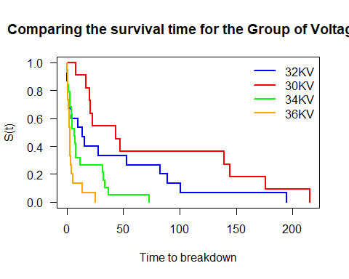

St <- km.voltages$surv  
logtime <- log(km.voltages$time)  
weibull <- log(-log(St))  
exponential <- -log(St)  
lognormal <- qnorm(St)  
  
voltages <- cbind(voltages,St,logtime,weibull,exponential,lognormal)

par(mfrow = c(1,3))  
  
### Weibull  
plot(logtime[1:10],weibull[1:10],col="red", pch = 19 , ylab= "Weibull position", xlab="Log(Faliure time)", xlim=c(-2,6), ylim= c(-3,1.5), main = "Weibull")  
points(logtime[12:25],weibull[12:25],col="blue", pch = 19)  
points(logtime[27:44],weibull[27:44],col="green", pch = 19)  
points(logtime[46:59],weibull[46:59],col="orange", pch = 19)  
legend("topleft", legend=c("30KV", "32KV", "34KV", "36KV"), col = c("red","blue","green","orange"), pch = 19, bty = "n")  
  
### Exponential  
plot(logtime[1:10],exponential[1:10],col="red", pch = 19 , ylab= "Exponential position", xlab="Log(Faliure time)", xlim=c(-2,6), ylim= c(0,3.5), main = "Exponential")  
points(logtime[12:25],exponential[12:25],col="blue", pch = 19)  
points(logtime[27:44],exponential[27:44],col="green", pch = 19)  
points(logtime[46:59],exponential[46:59],col="orange", pch = 19)  
legend("topleft", legend=c("30KV", "32KV", "34KV", "36KV"), col = c("red","blue","green","orange"), pch = 19, bty = "n")  
  
### lognormal  
plot(logtime[1:10],lognormal[1:10],col="red", pch = 19 , ylab= "lognormal position", xlab="Log(Faliure time)", xlim=c(-2,6), ylim= c(-1.8,2), main = "Lognormal")  
points(logtime[12:25],lognormal[12:25],col="blue", pch = 19)  
points(logtime[27:44],lognormal[27:44],col="green", pch = 19)  
points(logtime[46:59],lognormal[46:59],col="orange", pch = 19)  
legend("topright", legend=c("30KV", "32KV", "34KV", "36KV"), col = c("red","blue","green","orange"), pch = 19, bty = "n")

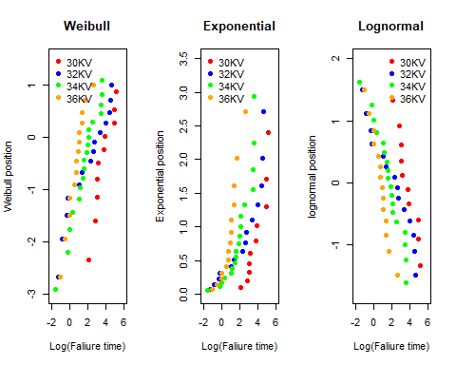

lm30 <- lm(weibull[1:10] ~ logtime[1:10])  
lm32 <- lm(weibull[12:25] ~ logtime[12:25])  
lm34 <- lm(weibull[27:44] ~ logtime[27:44])  
lm36 <- lm(weibull[46:59] ~ logtime[46:59])  
  
par(mfrow=c(2,2))  
  
plot(weibull[1:10] ~ logtime[1:10], pch=16, xlab="log(Faliure time)", sub="30KV",ylab="log(-log(S(t))")  
abline(lm30, col ="red")  
  
plot(weibull[12:25] ~ logtime[12:25], pch=16, xlab="log(Faliure time)", sub="32KV",ylab="log(-log(S(t))")  
abline(lm32, col ="blue")  
  
plot(weibull[27:44] ~ logtime[27:44], pch=16, xlab="log(Faliure time)", sub="34KV",ylab="log(-log(S(t))")  
abline(lm34, col ="green")  
  
plot(weibull[46:59] ~ logtime[46:59], pch=16, xlab="log(Faliure time)", sub="36KV",ylab="log(-log(S(t))")  
abline(lm36, col ="orange")

